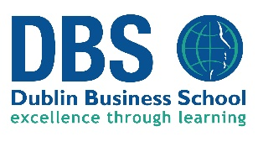 DBS Alert List 2019 CAO Intake

New Programmes:
- DB 510 BA (Hons) Audio Production and Music Project Management Level 8 – 3 Years
Entry Requirement: 2H5 and 4O6/H7 including Maths and English or Irish
This has replaced DB 530 Music Production and Entrepreneurship Level 8
- DB 534 Sound Engineering and Music Production Level 6 – 2 Years
Entry Requirements: 5O6/H7 requirement for Maths and English or Irish.
Withdrawn Courses:
- DB 578 BA Journalism and Media has been withdrawn
- DB 565 BA (Hons) Journalism has been withdrawn

Open Events:
Date | Time | Location
Tuesday 4th Dec | 5-7pm | Aungier Street Campus
Tuesday 8th Jan | 5-7pm | Aungier Street Campus
Wednesday 16th Jan | 4-7pm | Aungier Street Campus
Tuesday 22nd Jan | 5-7pm | Aungier Street Campus

Course Fees:
Please note DBS is an independent college and therefore fees apply. The fees for our undergraduate programmes for 2019/2020, are between €5,895 and €6,300 per annum.
Please note that the total fee includes all registration, tuition and examination costs. All our undergraduate courses have been approved for 20% tax relief.
Tax relief is available at the standard rate of 20% for the amounts exceeding €3,000 – up to €7,000. Further information can be found on the revenue website at http://www.revenue.ie/en/tax/it/leaflets/it31.html.

Programmatic Review:
In 2019, some of our programmes will undergo programmatic review which will mean updated to content to make them more relevant and contemporary. Some modules may incur title changes.
Contact details:
For school visit please contact Charlotte Hickey on 087 226 6732 or email Charlotte.Hickey@dbs.ie.

