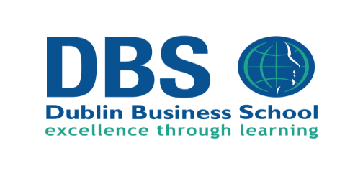
DBS CAO Alert List 2017
Six changes to the DBS courses listed in the 2017 CAO Handbook (Page 39).
New Courses
- DB 527 BA (Hons) Applied Social Care Level 8 - 4 year course
Entry Requirements: 2H5 &4 O6/ H7. O6/H7 requirement for English or another language and Maths
- Seeking CORU Accreditation

- DB 528 BA Applied Social Care Level 7 – 3 year course
Entry Requirements: 5 O6/ H7. O6/H7 requirement for English or another language and Maths
- Seeking CORU Accreditation

New BSc (Hons) Computing programmes:
- DB 501 BSc (Hons) Computing (Cloud Computing )
Entry Requirements: 2H5 & 4O6/H7. O6/H7 requirement for English or another language and H5/O5 for Maths

- DB 502 BSc (Hons) Computing (Data Analytics and Big Data)
Entry Requirements: 2H5 & 4O6/H7. O6/H7 requirement for English or another language and H5/O5 for Maths

- DB 503 BSc (Hons) Computing (Software Development)
Entry Requirements: 2H5 & 4O6/H7. O6/H7 requirement for English or another language and H5/O5 for Maths

- DB 504 BSc (Hons) Computing (Web and Cloud Technology)
Entry Requirements: 2H5 & 4 O6 / H7. O6/H7 requirement for English or another language and H5/O5 for Maths

Full Time Undergraduate Open Events 2016
Friday December 2nd 2016 (CAO open day) 11am-2pm Castle House Building, Great Georges Street, Dublin 2
Tuesday December 6th 2016, 5-7pm, Aungier Street, Dublin 2
Tuesday January 10th 2017, 5-7pm, Aungier Street, Dublin 2

